SIMATS ENGINEERING
ASSESSMENT TOOL 2
COURSE NAME: Cryptography and Network Security
COURSE CODE: CS A5113
COURSE OUTCOME COVERED
CO1: Apply classical encryption techniques using symmetric and asymmetric ciphers to encrypt and decrypt data for the ensuring data security. (BL3, BL4)
Assessment Tool Weightage: 20%
QUESTIONS: 5 Total Marks: 100 Annexure A
CONCEPT MAPPING
Code of Conduct:
I (Name / Reg No) certify that this submission is my original work and that I have adhered to the guidelines specified for this assessment.
I understand that any violation of academic integrity rules will result in disciplinary action.
Signature of the student:
Q. No | Understanding of Concepts  (25) | Experimental Design (30) | Use of Tools  (20) | Analysis of  Results (15) | Documentation (10) | Total Score  (out of 100)
1 | / 5 | / 6 | / 4 | / 3 | / 2
2 | / 5 | / 6 | / 4 | / 3 | / 2
3 | / 5 | /6 | / 4 | / 3 | / 2
4 | / 5 | / 6 | / 4 | / 3 | / 2
5 | / 5 | / 6 | / 4 | / 3 | / 2
OVERALL RUBRICS VALUE
 | / 5 | / 5 | / 4 | / 4 | / 2
 | / 25 | / 30 | / 20 | / 15 | / 10 | / 100

Annexure A
CONCEPT MAPPING
- Create a concept map linking the following: Security Attacks, Threats, Risks and Security Goals (Confidentiality, Integrity, Availability. Perform the following tasks:
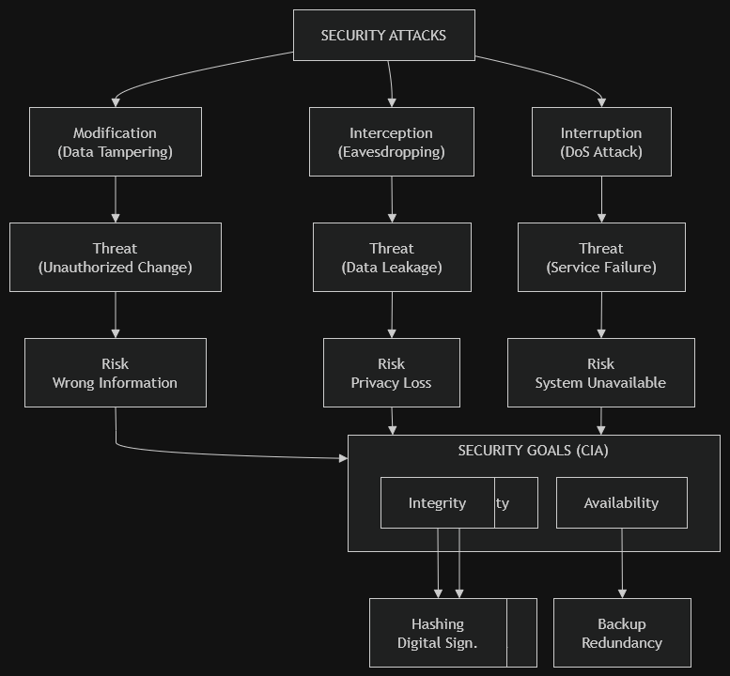
- Show how each attack leads to specific threats and risks:
Attack | Threat | Risk | Example
Interception | Data theft | Privacy loss | Hacker steals passwords from public Wi-Fi
Modification | Data tampering | Incorrect information | Bank transaction amount changed
Interruption | Service unavailable | Business loss | DDoS attack on website

b. Map how security goals help mitigate them Provide one real-world example for each link :

Security Goal | Protects Against | Example
Confidentiality | Interception | HTTPS encryption
Integrity | Modification | Digital signature
Availability | Interruption | Cloud backup during server failure

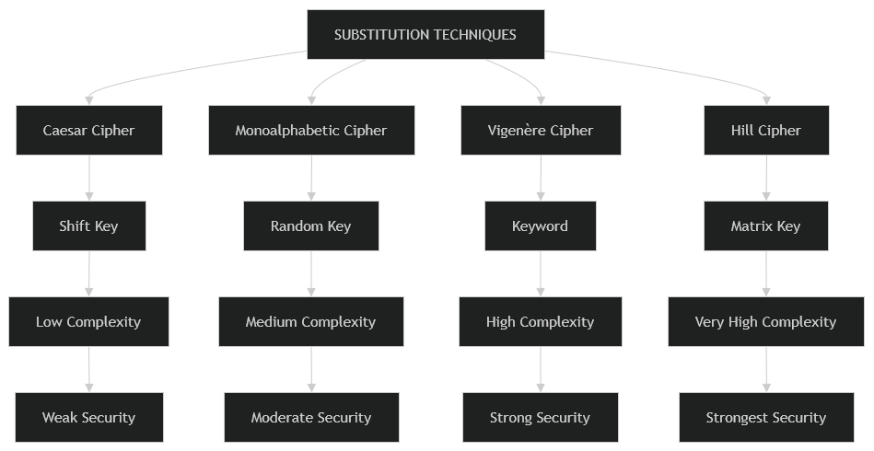
- Develop a concept map comparing substitution techniques: Caesar Cipher, Monoalphabetic Cipher, Vigenère Cipher and Hill Cipher. Perform the following tasks to connect based on: Key usage, Complexity and Security strength. Analyze which technique is most secure and why.

Comparison
Cipher | Key Usage | Complexity | Security
Caesar | Single shift | Low | Weak
Monoalphabetic | Random alphabet | Medium | Moderate
Vigenère | Keyword | High | Strong
Hill | Matrix | Very High | Strongest

Analysis
Most Secure: Hill Cipher
Reason:
- Uses matrix mathematics
- Encrypts multiple letters together
- Difficult to break using frequency analysis
- Large key space

3. Construct a concept map for Classical Encryption Schemes: Substitution Techniques and Transposition
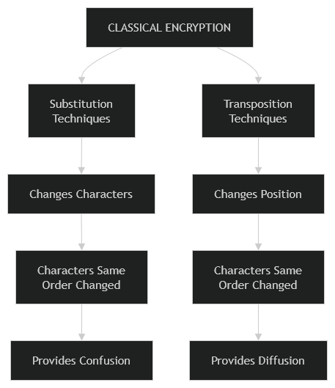
Techniques. Perform the following tasks:

a. Show differences and similarities
i.Map how each affects the Data structure and Security level

Effect on Data Structure & Security
Technique | Data Structure | Security
Substitution | Letters changed | Medium
Transposition | Position changed | Low-Medium

ii.Analyze which is more vulnerable to attacks and why
Substitution Cipher
Reason:
- Frequency analysis can reveal plaintext.
- Letter frequencies remain predictable.

- Create a concept map connecting Steganography concepts: Data Hiding, Watermarking and Survivability. Perform the following tasks:
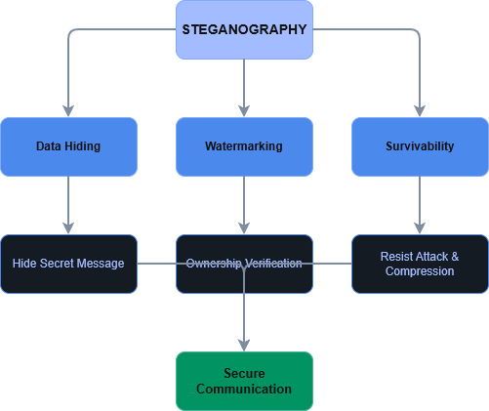

  - Show relationships between these concepts
- Data hiding conceals information.
- Watermarking proves ownership.
- Survivability ensures hidden data remains after attacks.
- Analyze how each contributes to secure communication
Concept | Contribution
Data Hiding | Secret communication
Watermarking | Copyright protection
Survivability | Reliable transmission

- Include one real-world application for each
Concept | Real-world Example
Data Hiding | Secret military communication
Watermarking | Copyright protection for images/videos
Survivability | Medical image authentication

5. Draw a concept map linking number theory concepts used in cryptography: Modular Inverse, Extended Euclid Algorithm, Fermat’s Little Theorem, Euler’s Phi Function and Euler’s Theorem. Perform the following tasks:
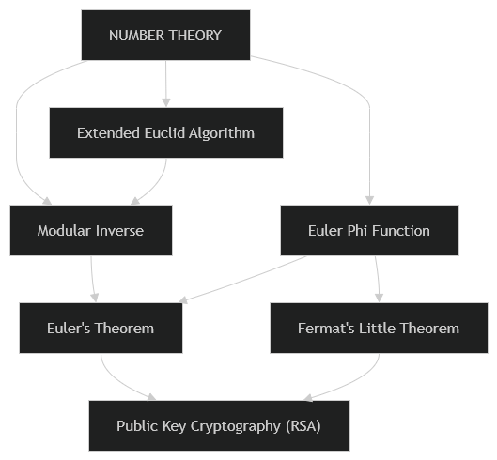
  - Show how each concept is mathematically connected
Concept | Connected To
Extended Euclid | Finds Modular Inverse
Modular Inverse | Used in RSA decryption
Euler Phi | Used in Euler's Theorem
Fermat's Little Theorem | Special case of Euler's Theorem
Euler's Theorem | Basis of RSA

  - Map their role in encryption/decryption
Concept | Role
Modular Inverse | Computes private key
Extended Euclid | Finds inverse efficiently
Euler Phi | Generates RSA keys
Fermat's Little Theorem | Prime number calculations
Euler's Theorem | RSA encryption and decryption

  - Analyze which concept is most critical for public key cryptography and justify
Euler's Theorem
Justification:
- Forms the mathematical foundation of RSA.
- Ensures that encrypted data can be correctly decrypted.
- Works together with Euler's Phi Function and Modular Inverse to generate secure public/private keys.
- Without Euler's Theorem, RSA public-key cryptography would not function correctly.

RUBRICS FOR CALCULATION:
Criteria | Weightage | Level 4 –  Exemplary | Level 3 –  Proficient | Level 2 –  Developing | Level 1 –  Beginning
Understanding of Concepts | 25 | Demonstrates thorough understanding and  effectively integrates  multiple  concepts/technologies | Good  understanding  with proper  integration of  most concepts | Basic  understanding; limited or partial integration | Poor  understanding; unable to  integrate  concepts
Experimental  Design | 30 | Well-planned, systematic implementation with  optimal solution | Correct  implementation with minor  issues | Basic  implementation with errors or  inefficiencies | Incorrect or  incomplete  implementation
Use of Tools | 20 | Effective and advanced use of tools/technologies with proper configuration | Appropriate  use of tools  with correct  execution | Limited or  inconsistent use of tools | Incorrect or  minimal use  of tools
Analysis of Results | 15 | Insightful analysis with accurate interpretation and validation of results | Good analysis  with reasonable interpretation | Basic analysis  with limited  insights | Poor or  incorrect  analysis of  results
Documentation | 10 | Clear, well-structured  documentation with  diagrams, code, and  results | Organized  documentation with necessary  details | Basic  documentation  with missing  details | Poor or  incomplete  documentation

